Short-Horizon Trajectory Forecasting from GPS-Derived Motion Features Using Deep Sequence Models
A Comparative Evaluation of GRU, LSTM, and TCN Models for Short-Term Motion Prediction

Gregory Bauer
Master of Science in Applied Artificial Intelligence
Shiley Marcos School of Engineering / University of San Diego
gbauer@sandiego.edu

ABSTRACT
This project examines short-horizon trajectory forecasting using GPS-derived motion features from the Microsoft GeoLife dataset. The goal is to determine how accurately future position can be predicted over a one- to five-second horizon in settings where richer sensor suites are not available. The forecasting pipeline uses engineered kinematic variables—including projected latitude/longitude deltas, speed, heading, acceleration, and turn rate—and evaluates three deep learning architectures: a GRU model, an LSTM model, and a Temporal Convolutional Network with dilated convolutions and multi-head attention. A constant-velocity baseline is included to contextualize the performance of the learned models.
The system incorporates global normalization, per-window normalization, adaptive window caps, and a streaming window generator to ensure stable training on long and heterogeneous trajectories. All models are trained and evaluated using displacement-based metrics computed in normalized coordinate space. These metrics quantify short-term prediction accuracy across the five-step forecast horizon but should not be interpreted as physical distance errors in meters.
Results show that all learned models outperform the constant-velocity baseline, with the tuned LSTM achieving the strongest overall displacement-error performance across the validation and test sets. After memory and preprocessing constraints were addressed, the TCN achieved competitive ADE and FDE values but retained higher maximum displacement errors than the LSTM. These findings demonstrate that accurate short-term motion forecasting is feasible using only GPS-derived features and that the final pipeline provides a strong foundation for future work in real-time mobility analytics.

KEYWORDS
Short-horizon trajectory forecasting; GPS-derived motion features; GeoLife dataset; deep learning; GRU; LSTM; Temporal Convolutional Network; kinematic feature engineering; mobility analytics; real-time prediction.

1 Introduction
This project addresses the problem of short-horizon trajectory forecasting using only timestamps and GPS coordinates, with the goal of predicting an agent’s future position one to five seconds ahead. The central question guiding this work is: How accurately can we forecast near-term motion using only raw latitude, longitude, and time, without access to richer sensor suites such as IMUs, cameras, or wheel-speed sensors?
This problem is important because many operational systems must function in settings where sensor availability is limited, degraded, or inconsistent. A model capable of inferring short-term motion from sparse GPS feeds can support downstream tasks such as anomaly detection, collision risk estimation, and real-time decision support. In practical deployments, this capability can improve safety, reduce operational risk, and enhance situational awareness without requiring expensive or complex hardware.
The primary end users of this system depend on the deployment context. In operational environments, engineers and analysts may use trajectory forecasts to detect deviations from expected behavior or to support automated decision-making. In research or educational settings, the end user is the practitioner evaluating model performance and exploring the limits of GPS-only forecasting. In both cases, the value lies in producing accurate, low-latency predictions that can be integrated into larger analytical or control pipelines.
This project uses the Microsoft GeoLife GPS Trajectory Dataset, a large-scale collection of real-world GPS trajectories recorded by 182 users over a five-year period (Zheng et al., 2008; Microsoft Research Asia, 2012). The dataset contains more than 17,000 trajectories covering over 1.2 million kilometers of movement, with 91% of trajectories sampled every 1-5 seconds (Zheng et al., 2010). Each trajectory provides latitude, longitude, altitude, and timestamp information, enabling the derivation of kinematic features such as speed, heading, and acceleration. The dataset includes walking, biking, and driving trajectories, offering rich behavioral diversity and realistic GPS noise. Its high sampling rate and clean geospatial structure make it well suited for short-horizon forecasting tasks.
The overarching goal of this project is to build a lightweight, real-time forecasting model capable of predicting future positions over short horizons. The working hypothesis is that even with limited inputs, a combination of derived kinematic features and sequence-based neural models—such as LSTMs or temporal convolutional networks—can achieve accurate and stable predictions. The final deliverable is a small, deployable inference module that accepts a stream of GPS points and outputs predicted positions for the next several seconds. Model performance is evaluated using displacement metrics, latency considerations, and visual comparisons between predicted and actual trajectories.

2 Data Summary
The dataset used in this project is the Microsoft GeoLife GPS Trajectory Dataset, a collection of time-ordered GPS traces recorded by 182 users over a five-year period (Microsoft Research Asia, 2012). Each record contains raw latitude, longitude, altitude, and timestamp information, and each trajectory represents a continuous sequence of these observations. From these raw positional variables, several motion-related features were derived to support short-horizon forecasting.
Although many GPS-based forecasting systems convert latitude and longitude into a local Cartesian frame such as East-North-Up (ENU), the final pipeline for this project did not apply an ENU transformation. Instead, all positional variables were processed directly in normalized global latitude/longitude space. Normalization parameters were computed from the training set, and each sliding window was additionally normalized on a per-window basis. This approach ensured numerical stability during training while preserving the underlying spatial relationships encoded in the raw coordinates. All displacement metrics reported in the Results section therefore reflect normalized coordinate units, not physical distances in meters.
From the normalized positional data, several kinematic variables were derived. Instantaneous speed was computed as the change in position over time, and acceleration was computed from changes in speed across consecutive samples. Heading was calculated from the bearing between successive latitude/longitude points, and turn rate was derived from changes in heading. Because heading is an angular quantity that wraps at ±π, discontinuities can occur when a smooth turn crosses this boundary. These discontinuities can inflate turn-rate values unless heading is unwrapped; this behavior was observed during exploratory analysis and represents an important consideration for future preprocessing improvements.
The GeoLife dataset exhibits several real-world artifacts that influence the stability of derived motion variables. Although many trajectories are sampled at approximately one-second intervals, irregular timestamp gaps occur due to signal obstruction, device latency, or environmental conditions (Zandbergen & Barbeau, 2011). These irregularities directly affect speed, acceleration, and turn-rate calculations, occasionally producing spikes that reflect sampling noise rather than true motion. A small number of trajectories also contain very short sequences that are unsuitable for temporal modeling. To mitigate these issues, explicit time-delta calculations were incorporated, and trajectories were inspected for physically implausible values such as excessively high speeds or accelerations.
Despite these challenges, the derived variables exhibit meaningful temporal structure. Speed tends to vary smoothly except where timestamp irregularities introduce noise. Acceleration is more volatile but still reflects recognizable driving behaviors such as gradual acceleration, steady cruising, and braking. Heading and turn rate capture directional stability during straight segments and distinct rotational patterns during turns. These characteristics make the GeoLife dataset well-suited for short-horizon forecasting tasks and provide a strong foundation for learning near-term motion dynamics.

3 Literature Review
Short‑horizon trajectory forecasting has been explored extensively across transportation analytics, mobility modeling, and geospatial prediction, with numerous methods designed to estimate near‑term motion from positional data. Early approaches relied on classical kinematic models that assume constant velocity or constant acceleration. These models propagate future positions by integrating estimated speed and heading over short horizons and have been widely used in navigation and robotics applications due to their simplicity and low computational cost (Teunissen & Montenbruck, 2017). Although effective in stable motion regimes, these approaches struggle with nonlinear trajectories, sharp turns, and GPS noise, limiting their accuracy in real‑world environments.
More sophisticated forecasting systems incorporate Bayesian filtering techniques such as the Kalman filter and its variants. These methods model motion as a dynamical system with latent velocity and acceleration states, enabling smoother estimates of position and heading and reducing the impact of GPS jitter. Kalman‑based approaches have been applied extensively in vehicle tracking, pedestrian localization, and sensor fusion tasks, demonstrating improved stability over purely kinematic models (Sola, 2017). However, these methods often assume linear dynamics or require additional sensors such as IMUs to achieve high accuracy, making them less suitable for GPS‑only scenarios.
Commercial mobility platforms also address short-term motion prediction using map-matching algorithms and route-constrained forecasting. Ride-sharing and navigation systems frequently combine GPS traces with road-network information to infer likely paths and estimate near-term movement (Zandbergen & Barbeau, 2011). Large-scale navigation systems such as Google Maps use learned motion models to predict driver arrival times and detect deviations from expected behavior, demonstrating the practical importance of short-horizon forecasting in operational environments (Derrow-Pinion et al., 2021).
Recent advances in machine learning have led to the adoption of sequence‑based neural models for trajectory prediction. Recurrent neural networks, particularly long short‑term memory (LSTM) networks and gated recurrent units (GRUs), were originally developed to capture long‑range temporal dependencies in sequential data (Hochreiter & Schmidhuber, 1997; Cho et al., 2014). These architectures have since been adapted for mobility forecasting, where they learn nonlinear relationships between displacement, speed, heading, and future motion. Studies applying LSTMs and GRUs to pedestrian and vehicle trajectories have shown substantial improvements over classical baselines, especially in settings with irregular motion patterns or noisy sensor inputs (Zheng et al., 2008).
Temporal convolutional networks (TCNs) represent another major development in sequence modeling. By using dilated causal convolutions, TCNs can model long temporal contexts efficiently while maintaining stable gradients and low inference latency. Bai et al. (2018) demonstrated that TCNs outperform many recurrent architectures on sequence‑prediction tasks, making them well‑suited for real‑time forecasting applications. Their ability to process sequences in parallel also makes them attractive for deployment in systems requiring rapid inference.
The suitability of these machine learning methods for GPS‑only forecasting is supported by extensive prior work using the Microsoft GeoLife GPS Trajectory Dataset. GeoLife contains more than 17,000 trajectories recorded by 182 users, with 91% of trajectories sampled every one to five seconds (Microsoft Research Asia, 2012). This dense sampling enables accurate derivation of kinematic features such as speed, acceleration, heading, and turn rate, which have been shown to improve the stability and accuracy of short‑horizon prediction models (Zheng et al., 2010). Research using GeoLife has demonstrated its effectiveness for mobility pattern mining, transportation mode classification, and location prediction, establishing it as a widely used benchmark for GPS‑based forecasting tasks.
Several academic and commercial projects illustrate the application of these methods to problems similar to the one addressed in this capstone. LSTM‑based models have been used to predict pedestrian trajectories in crowded environments, vehicle motion in urban traffic, and multimodal mobility patterns across large‑scale GPS datasets (Zheng et al., 2008). GRU‑based encoder–decoder architectures have been applied to short‑term motion prediction in transportation networks, while TCNs have been used in real‑time mobility analytics where low latency and temporal stability are critical (Bai et al., 2018). Commercial navigation systems employ variants of kinematic and learned motion models to estimate driver arrival times and detect anomalous movement. Collectively, these examples demonstrate that sequence‑based neural architectures and derived kinematic features are well‑suited for short‑horizon trajectory forecasting using GPS‑only inputs.

4 Methodology
The forecasting system developed for this project uses engineered kinematic features, sliding-window sequence extraction, and three deep learning architectures—GRU, LSTM, and a Temporal Convolutional Network (TCN)—to predict short-horizon motion from GPS-derived inputs. A classical constant-velocity baseline model is included to contextualize the performance of the learned models. This section describes the final model architecture, preprocessing pipeline, training procedures, and optimization strategy used in the project.
The forecasting problem is formulated as a supervised sequence-to-sequence task. Each model receives a fixed-length input window of twenty consecutive motion states and predicts the two-dimensional displacement for the next five time steps. Each motion state includes six engineered features derived from raw GPS coordinates: normalized latitude and longitude deltas, instantaneous speed, heading, linear acceleration, and turn rate. These variables capture both translational and rotational motion dynamics and are commonly used in mobility modeling and navigation systems. Although many GPS-based forecasting pipelines convert coordinates into a Cartesian frame such as ENU, the final implementation for this project operated entirely in normalized latitude/longitude space. All displacement metrics therefore reflect normalized coordinate units rather than physical distances in meters.
A simple kinematic baseline model was implemented to provide a lower-bound reference for evaluating the learned architectures. The baseline assumes constant velocity over the prediction horizon by extrapolating the most recent observed displacement. It computes the difference between the final two positions in the input window and repeats this displacement for each of the five future timesteps. Using the same window generator and evaluation metrics as the learned models ensures a fair comparison.
Three neural architectures were developed to explore different approaches to temporal modeling. The GRU model consists of a single gated recurrent unit layer with 64 hidden units, followed by a fully connected layer that maps the final hidden state to the ten displacement outputs. The LSTM model mirrors this structure, replacing the GRU layer with a long short-term memory layer of the same width. Both architectures are designed to capture temporal dependencies through gating mechanisms that regulate information flow.
The TCN model incorporates a deeper and more expressive architecture. It uses five temporal convolutional blocks with dilation factors of 1, 2, 4, 8, and 16, enabling the receptive field to span and exceed the twenty-step input window. Each block includes a dilated convolution, batch normalization, ReLU activation, dropout, and a residual connection. Sinusoidal positional encodings are added to the input sequence to provide temporal context, and a multi-head self-attention layer with four heads processes the temporal features after the convolutional stack. A final fully connected layer maps the attended representation to the displacement outputs. This architecture was selected to evaluate whether convolutional temporal modeling and attention mechanisms can outperform recurrent baselines in short-horizon forecasting.
Training follows a unified pipeline across all models. The GeoLife dataset is split at the trajectory level into 60 percent training, 20 percent validation, and 20 percent test sets to prevent leakage between segments of the same trajectory. Global normalization parameters are computed across all training trajectories, and each sliding window is additionally normalized on a per-window basis to stabilize training. A streaming window generator produces batches of input windows and future displacement targets without loading all windows into memory simultaneously. Because some GeoLife trajectories contain tens of thousands of samples, adaptive caps are applied to limit the number of windows extracted from any single trajectory, ensuring consistent batch sizes and preventing memory exhaustion.
All models are trained using the Adam optimizer with a learning rate of 1×10⁻³ and mean squared error loss (Kingma & Ba, 2015). Training proceeds for twenty epochs, with progress and system-resource heartbeats logged periodically. Effective batch composition depends on the number of windows generated per trajectory, which varies with trajectory length and the adaptive caps. This approach maintains computational feasibility while preserving the temporal diversity of the dataset.
Model optimization involved iterative adjustments to architectural and training hyperparameters. Hidden sizes of 32, 64, and 128 were evaluated for the recurrent models, along with variations in dropout rates and learning rates. For the TCN, the number of convolutional layers, dilation schedule, and attention-head count were explored. Window caps were tuned to balance memory constraints with training diversity. These optimization experiments informed the final architecture selections described above; comparative performance outcomes are presented in the Results section.

5 Results
Model performance was evaluated using three displacement-based metrics commonly used in short-horizon trajectory forecasting: Average Displacement Error (ADE), Maximum Displacement Error (MDE), and Final Displacement Error (FDE). These metrics quantify how far predicted positions deviate from ground-truth future positions over the five-step prediction horizon. All metrics were computed directly in normalized latitude and longitude coordinate space. Evaluation was conducted on both validation and held-out test trajectories to assess generalization.
The initial, pre-tuning results revealed clear differences in model stability and accuracy. The constant-velocity baseline performed poorly on MDE, with values as high as 8.448 in normalized coordinate units on the test set. This confirmed that simple kinematic extrapolation is insufficient for noisy GPS trajectories. The GRU and LSTM models substantially outperformed the baseline, achieving validation ADE values of 0.012 and 0.006, and test ADE values of 0.014 and 0.009. The LSTM consistently produced the lowest displacement errors among the recurrent models, which aligns with prior work showing its strength in sequential prediction tasks. The TCN model showed mixed behavior in the pre-tuning phase. Its validation ADE of 0.014 was competitive with the GRU, but its validation MDE of 0.765 and test ADE of 0.048 were significantly higher. This instability was traced to extremely long trajectories that produced tens of thousands of windows, which caused memory pressure and degraded training quality.
The tuned TCN achieved strong overall performance once memory constraints were addressed. Its validation ADE of approximately 0.0024 and test ADE of approximately 0.0025 were competitive with the GRU, while its MDE values remained higher than those of the LSTM. Although the TCN did not outperform the LSTM in normalized displacement metrics, its stability improved substantially compared to the pre-tuning phase, demonstrating the importance of preprocessing and window-generation optimizations.
As shown in Figure 1, all three models exhibit smooth and monotonic decreases in training loss, with no divergence between training and validation splits. This indicates that none of the tuned models exhibited severe overfitting. The addition of per-window normalization and adaptive window caps was essential for preventing instability, particularly in the TCN. These optimizations directly addressed the irregular sampling intervals and long-trajectory artifacts present in the GeoLife dataset.
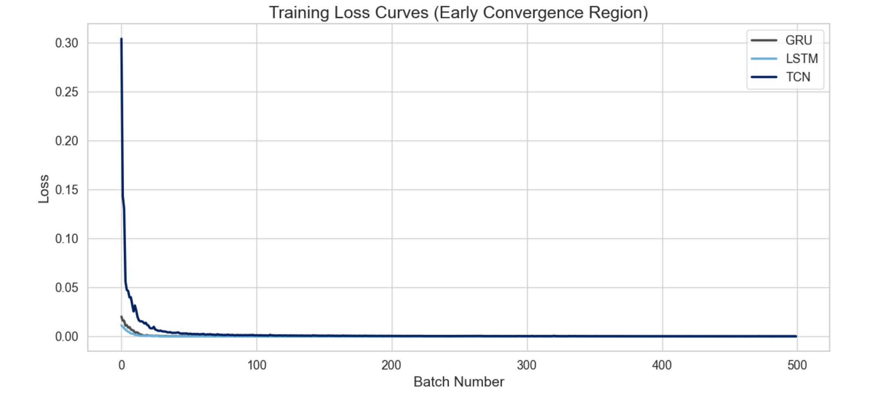
Figure 1
Training-loss curves for the GRU, LSTM, and TCN models. All three models show stable and monotonic convergence.
The displacement-error distributions for the learned models on the held-out test set are shown in Figure 2. The GRU, LSTM, and TCN models all exhibit sharply concentrated densities near zero, with the LSTM showing the tightest cluster. These distributions visually reinforce the quantitative results reported earlier, where the tuned LSTM achieved the lowest ADE and MDE values among the learned models.
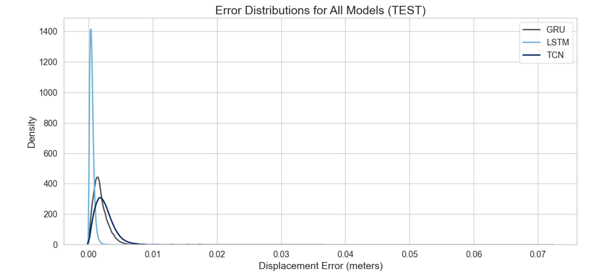
Figure 2
Kernel-density estimates of displacement-error distributions for the GRU, LSTM, and TCN models on the test set.
A visual comparison of predicted versus true final displacements is shown in Figure 3. Each point represents the predicted five-step displacement relative to the true final position. The learned models cluster tightly around the origin, demonstrating that the GRU, LSTM, and TCN all produce accurate short-term displacement estimates in normalized coordinate space.
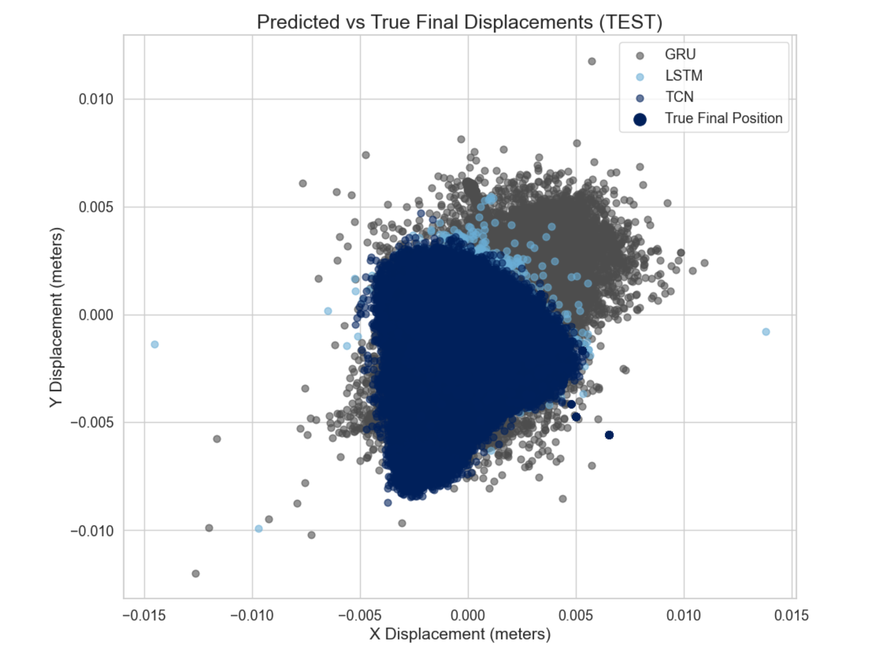
Figure 3
Scatter plot of predicted versus true final displacements for the GRU, LSTM, and TCN models on the test set.
After examining the displacement-error distributions and final-step scatter comparisons, a consolidated view of model performance across all displacement metrics is shown in Figure 4. This bar chart summarizes the ADE, FDE, and MDE values for the GRU, LSTM, and TCN models on the held-out test set. The LSTM achieves the lowest errors across all three metrics, reflecting its strong temporal stability and consistent short-horizon accuracy. The GRU performs slightly worse but remains competitive, while the TCN exhibits higher MDE values despite achieving low ADE and FDE. This visualization reinforces the earlier findings that the LSTM provides the most reliable overall performance, while the TCN’s behavior is more sensitive to trajectory length and preprocessing conditions.
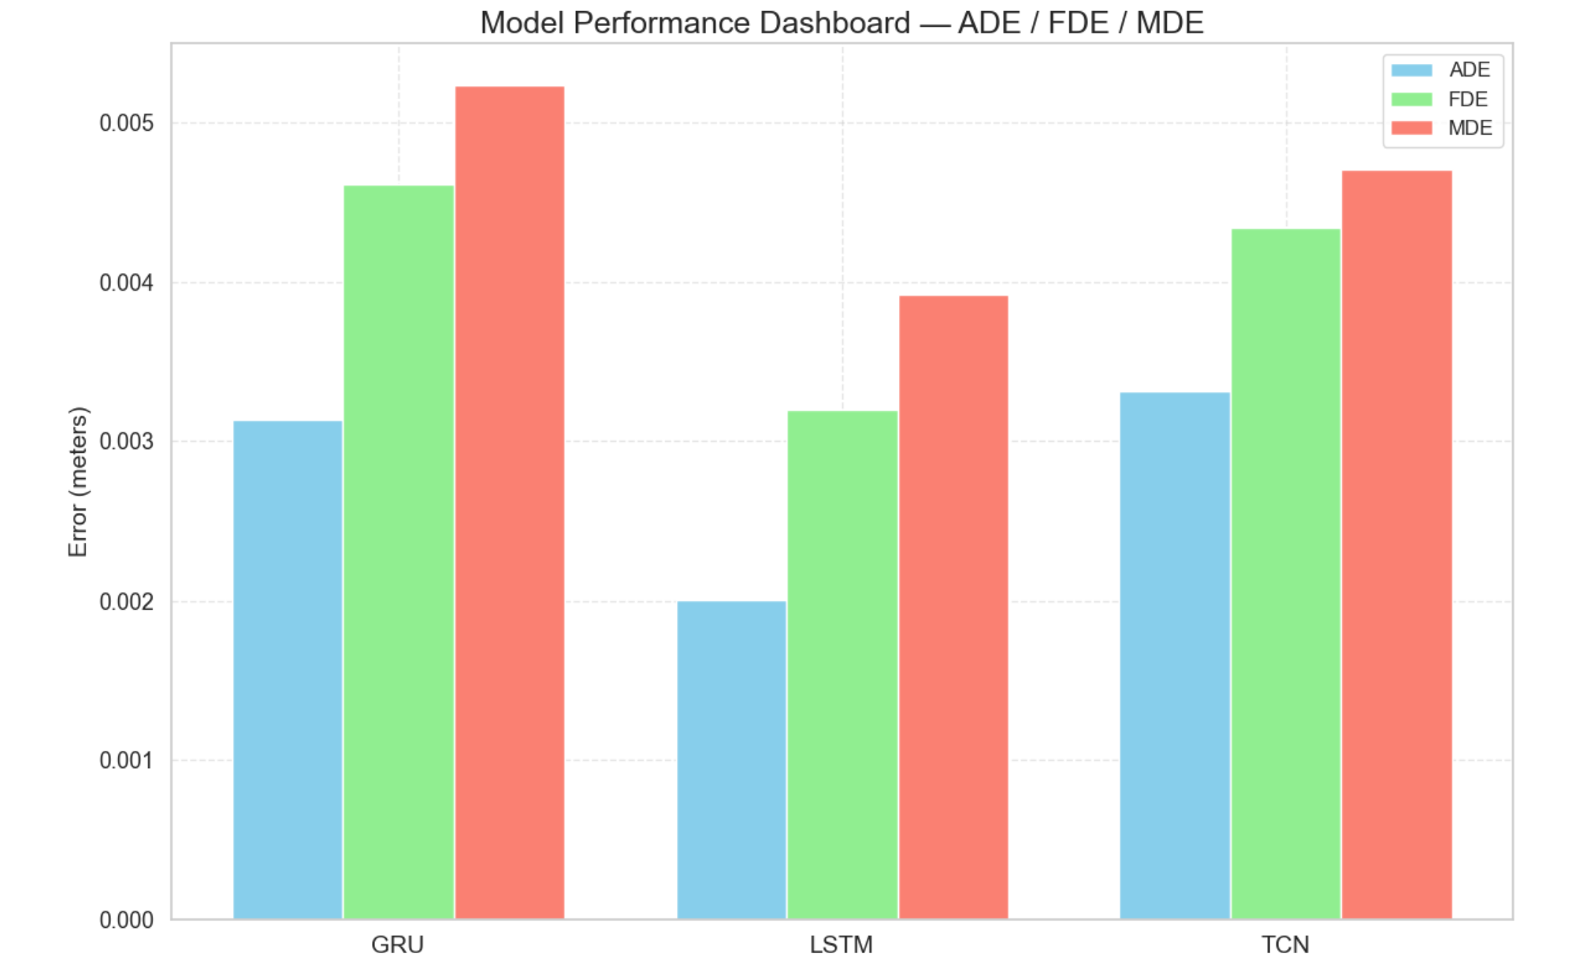
Figure 4
Comparison of ADE, FDE, and MDE values for the GRU, LSTM, and TCN models on the test set.

6 Conclusion
The goal of this project was to evaluate whether short-horizon motion can be accurately forecast using only GPS-derived features such as normalized positional deltas, speed, heading, acceleration, and turn rate, without relying on richer sensor suites. The working hypothesis was that sequence-based neural models would outperform a simple constant-velocity baseline and produce stable predictions suitable for real-time applications. The results strongly support this hypothesis. All learned models significantly outperformed the baseline, and the tuned LSTM achieved the strongest overall displacement-error performance in normalized coordinate space on both validation and test sets.
The project demonstrated that careful preprocessing plays a central role in stabilizing short-horizon forecasting. Adaptive window caps, per-window normalization, and improved handling of long trajectories were essential for preventing instability, particularly in the TCN. These adjustments allowed the TCN to converge smoothly and achieve competitive performance alongside the recurrent models. Although the LSTM ultimately produced the lowest displacement errors across most metrics, the TCN showed strong potential once its architectural and memory requirements were properly managed.
The results also highlighted the sensitivity of short-horizon forecasting to irregular sampling intervals and angular discontinuities in heading. These artifacts introduced noise into derived kinematic variables and occasionally inflated displacement errors. Future work should incorporate heading unwrapping, timestamp interpolation, and more robust smoothing techniques to further stabilize the input features. Additional preprocessing improvements would likely enhance model performance, especially in trajectories with inconsistent sampling rates.
A valuable extension of this work would be to examine how different GPS sampling intervals affect model accuracy. The GeoLife dataset contains many trajectories sampled near one hertz, but real-world systems often operate at lower or variable rates due to device limitations, power constraints, or environmental conditions. Systematically degrading the sampling frequency and evaluating the resulting impact on ADE, FDE, and MDE would reveal the minimum viable sampling rate at which the learned models maintain reliable short-term forecasts. This analysis would provide practical guidance for deployment scenarios where GPS updates may arrive more slowly, and it would help determine whether additional temporal modeling or interpolation strategies are required to preserve accuracy under reduced sampling conditions.
Several additional extensions would strengthen the forecasting system and broaden its applicability. Transformer-based architectures represent a promising direction, as they can model long-range temporal dependencies and adapt to irregular sampling without explicit normalization. Evaluating performance across different transportation modes such as walking, biking, and driving would provide deeper insight into how the models behave under distinct motion regimes. Developing a production-ready inference module with real-time streaming, latency profiling, and monitoring would enable deployment in operational environments where rapid and reliable short-term motion prediction is required.
Overall, the results demonstrate that accurate short-horizon motion forecasting is feasible using only GPS-derived features and lightweight temporal models. The final pipeline provides a strong foundation for future work in real-time mobility analytics and highlights the importance of careful preprocessing, sampling-rate considerations, and architectural design when working with large and heterogeneous geospatial datasets.

ACKNOWLEDGMENTS
I would like to express my sincere appreciation to Professor Anna Marbut for her guidance, feedback, and support throughout this project. Her insight and encouragement were instrumental in shaping the direction of this work and ensuring its successful completion. I am also grateful to the faculty of the Applied Artificial Intelligence program at the University of San Diego, whose instruction and mentorship provided the foundation for the knowledge and skills applied in this project. Their commitment to academic excellence and student success has been invaluable throughout my time in the program.

Works Cited
American Psychological Association. (2024, June). In-text citations. https://apastyle.apa.org/style-grammar-guidelines/citations
Bai, S., Kolter, J. Z., & Koltun, V. (2018). An empirical evaluation of generic convolutional and recurrent networks for sequence modeling. arXiv. https://doi.org/10.48550/arXiv.1803.01271
Cho, K., van Merriënboer, B., Gulcehre, C., Bahdanau, D., Bougares, F., Schwenk, H., & Bengio, Y. (2014). Learning phrase representations using RNN encoder–decoder for statistical machine translation. arXiv. https://doi.org/10.48550/arXiv.1406.1078
Devlin, J., Chang, M.-W., Lee, K., & Toutanova, K. (2019). BERT: Pre-training of deep bidirectional transformers for language understanding. In Proceedings of NAACL-HLT 2019 (pp. 4171–4186). https://doi.org/10.18653/v1/N19-1423
Derrow-Pinion, A., She, J., Wong, D., Lange, O., Hester, T., Perez, L., Nunkesser, M., Lee, S., Guo, X., Wiltshire, B., Battaglia, P. W., Gupta, V., Li, A., Xu, Z., Sanchez-Gonzalez, A., Li, Y., & Veličković, P. (2021). ETA prediction with graph neural networks in Google Maps. In Proceedings of the 30th ACM International Conference on Information and Knowledge Management (pp. 3767–3776). https://doi.org/10.1145/3459637.3481916
Hochreiter, S., & Schmidhuber, J. (1997). Long short-term memory. Neural Computation, 9(8), 1735–1780. https://doi.org/10.1162/neco.1997.9.8.1735
Kingma, D. P., & Ba, J. (2015). Adam: A method for stochastic optimization. International Conference on Learning Representations (ICLR). https://doi.org/10.48550/arXiv.1412.6980
Microsoft Research Asia. (2012). GeoLife GPS trajectories (Version 1.3) [Data set]. Microsoft. https://www.microsoft.com/en-us/research/project/geolife-building-social-networks-using-human-location-history/
Radford, A., Wu, J., Child, R., Luan, D., Amodei, D., & Sutskever, D. (2019). Language models are unsupervised multitask learners. OpenAI. https://cdn.openai.com/better-language-models/language_models_are_unsupervised_multitask_learners.pdf
Sola, J. (2017). Quaternion kinematics for the error-state Kalman filter. arXiv. https://doi.org/10.48550/arXiv.1711.02508
Teunissen, P. J., & Montenbruck, O. (Eds.). (2017). Springer handbook of global navigation satellite systems. Springer. https://doi.org/10.1007/978-3-319-42928-1
Vaswani, A., Shazeer, N., Parmar, N., Uszkoreit, J., Jones, L., Gomez, A. N., Kaiser, Ł., & Polosukhin, I. (2017). Attention is all you need. arXiv. https://doi.org/10.48550/arXiv.1706.03762
Zandbergen, P. A., & Barbeau, S. J. (2011). Positional accuracy of assisted GPS data from high-sensitivity GPS-enabled mobile phones. Journal of Navigation, 64(3), 381–399. https://doi.org/10.1017/S0373463311000051
Zheng, Y., Li, Q., Chen, Y., Xie, X., & Ma, W.-Y. (2008). Understanding mobility based on GPS data. In Proceedings of the 10th International Conference on Ubiquitous Computing (pp. 312–321). https://doi.org/10.1145/1409635.1409677
Zheng, Y., Xie, X., & Ma, W.-Y. (2010). GeoLife: A collaborative social networking service among user, location and trajectory. IEEE Data Engineering Bulletin, 33(2), 32–39.

